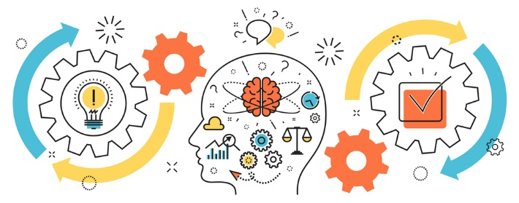
State of Kansas
Project Management
Class Offerings
Emotional Intelligence for Project Managers
August 13-14, 2024 8:30am-4:30pm Virtual
$260 per participant* PDU’s – 19.50

This two-day course will focus on ways project managers can understand and use emotional intelligence in their personal lives and in the workplace. Students will be introduced to the basic concepts of emotional intelligence and will learn how to apply them to their project goals. Students will learn to evaluate themselves, their project teams, and their stakeholders. Students will be able to utilize the concepts in order to lead a high-functioning team to project success.

Objectives
- Define emotional intelligence concepts
- Review the history of emotional intelligence
- Identify emotional intelligence models
- List the attributes and skills of an effective project manager
- Identify areas of improvement needed
- Self-awareness
- Self-management
- Social awareness
- Relationship management
- Team leadership
- Identify the families of emotion and emotional red flags
- Identify and explore techniques to improve self-awareness.
- Discuss self-control
- Identify emotional triggers
- Explore a process for managing emotions

- Registration: Please register through our KITO website: ebit.ks.gov/kito/training
Once there please select the class you wish to attend, complete the form online and email to KITO@ks.gov. If you have any questions please contact Celena Ramirez at 785-368-7161, or celena.m.ramirez@ks.gov.

Cancelation Policy: Cancelations up to 20 business days prior to class date are eligible for a 100% refund. Less than 20 business days there is NO refund.

The Mathis Group, Inc. is a Project Management Institute (PMI) Registered Global Educational Provider.
*2.5% administrative fee included
PMI’s Talent Triangle Breakdown for this class: Technical=6 Leadership=11.5 Strategic= 2

